Login Instructions
Access to the database is for active, non-student members of CSMLS.
On the click of Login, you will see a screen similar to shown below
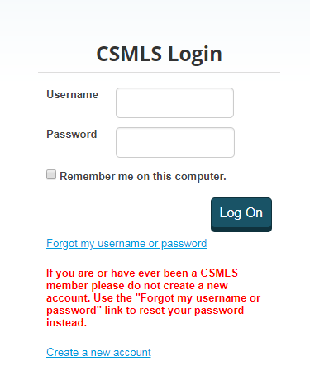
Active members can access the database using their CSMLS id. On successful login, you will be taken to the Curriculum database where you will be able to search Simulations based on your selection

You will receive an error message on login if you are not an active member. If you get an error message for an active type membership, please contact administrator at info@csmls.org or Membership and Finance 1-800-263-8277

